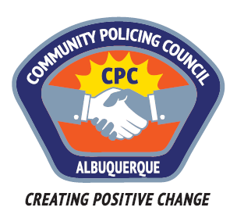

Foothills Area Command Community Policing Council

AGENDA

Monday 10 April 2017 6:00pm – 7:50pm
Holiday Park Community Center
11710 Comanche Road NE, Albuquerque, NM 87111
- Call to order—Carolyn Wilson, Chair
- Introductions of Council and Visitors
  - Welcome new Council members Kelly Baughman, Valerie St John, Mark Bourton,
- Review/amendment/approval of Agenda
- Review/correction/approval of Minutes from March 13th meeting *
- APD Communications—
  - Report on Foothills Crime Report from APD
  - Reports from Celina Espinoza and/or Nicole Chavez-Lucero
- Featured Speakers: Lt Bret White—The new Use of Force Policy (continuing presentation)
- Pulse of the Neighborhoods—reports from CPC members and citizens
- Recommendations
- Other business
  - Recommendations for speakers
- Adjournment
Next meeting: Monday 8 May 2017 6-7:50 pm Holiday Park Community Center
Comments or questions:
Carolyn Wilson, CPC Chair (505) 710-6074 carowilson23@msn.com
Doug Brosveen, CPC Vice-Chair (505) 263-1022 dbrosveen@msn.com
Philip Crump, CPC Facilitator (505) 989-8558 philip@pcmediate.com

* Minutes of CPC meetings are posted at http://www.cabq.gov/police/community-policing-council/community-policing-council-minutes

